Koch Snowflake Report

Jacob Regan

For this report, we implemented a simple program in OpenGL to create a Koch snowflake. Starting with an equilateral triangle with sides of length d, we can recursively generate the snowflake by iterating n times according to the following procedure.

1. Divide each line segment into three equal parts.
2. Take the middle part for each line segment and create an equilateral triangle using the part as a base. It should point outward.
3. Remove part of the line segment that served as the base.

I implemented this in my performStep() method. I had program draw the end result as well as print information for each iteration. The results for n=10 and d=1 are shown below. Of note, we can see that the total area is converging towards a value of approximately 0.692… This is an important property of Koch snowflakes, whose areas converge towards $\frac{2d^{2}\sqrt{3}}{5}$, where d is the original side length. In our case, the value is converging towards $\frac{2\sqrt{3}}{5}$. I have also included images of snowflakes with various values for n at the end.

|  |
| --- |
| Iteration (n): 0 |
| Number of segments: 3 |
| Perimeter: 3.0000 |
| Area: 0.4330127083 |
| ---------- |
| Iteration (n): 1 |
| Number of segments: 12 |
| Perimeter: 4.0000 |
| Area: 0.5773502769 |
| ---------- |
| Iteration (n): 2 |
| Number of segments: 48 |
| Perimeter: 5.3333 |
| Area: 0.6415003079 |
| ---------- |
| Iteration (n): 3 |
| Number of segments: 192 |
| Perimeter: 7.1111 |
| Area: 0.6700114330 |
| ---------- |
| Iteration (n): 4 |
| Number of segments: 768 |
| Perimeter: 9.4815 |
| Area: 0.6826830442 |
| ---------- |
| Iteration (n): 5 |
| Number of segments: 3072 |
| Perimeter: 12.6420 |
| Area: 0.6883148715 |
| ---------- |
| Iteration (n): 6 |
| Number of segments: 12288 |
| Perimeter: 16.8560 |
| Area: 0.6908179058 |
| ---------- |
| Iteration (n): 7 |
| Number of segments: 49152 |
| Perimeter: 22.4746 |
| Area: 0.6919303656 |
| ---------- |
| Iteration (n): 8 |
| Number of segments: 196608 |
| Perimeter: 29.9662 |
| Area: 0.6924247921 |
| ---------- |
| Iteration (n): 9 |
| Number of segments: 786432 |
| Perimeter: 39.9549 |
| Area: 0.6926445372 |
| ---------- |
| Iteration (n): 10 |
| Number of segments: 3145728 |
| Perimeter: 53.2732 |
| Area: 0.6927422017 |
| ---------- |

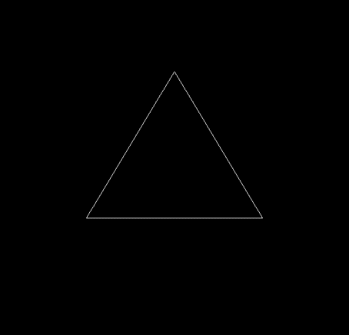

.n=0

2. n=1

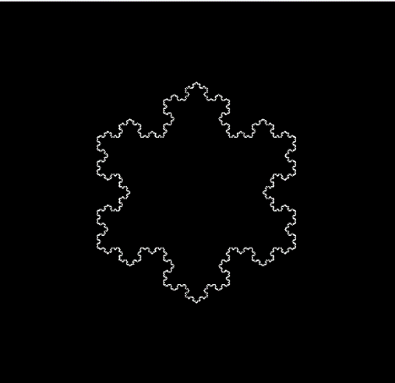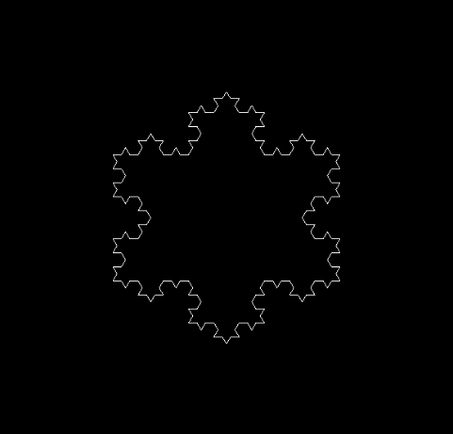

. n=10

. n=3